Python Programming Lab Task Sets

Set 4
- Q1. Create a function to reverse a list in Python. Use an AI tool to suggest alternative implementations. Test and compare the performance of each version.
PROMT
Create a function to reverse a list in Python. Use an AI tool to suggest alternative implementations. Test and compare the performance of each version.
GIVE SINGLE ACCURATE ANSWER
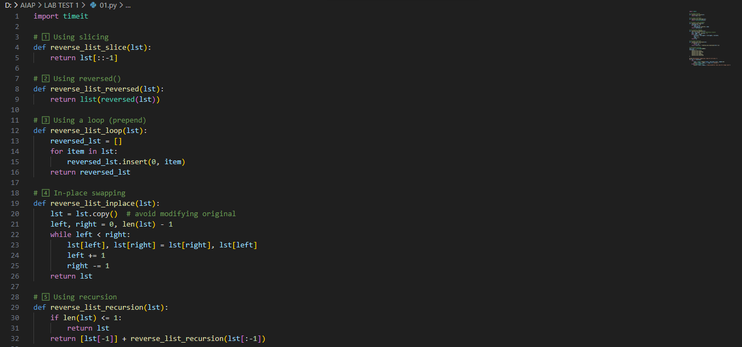
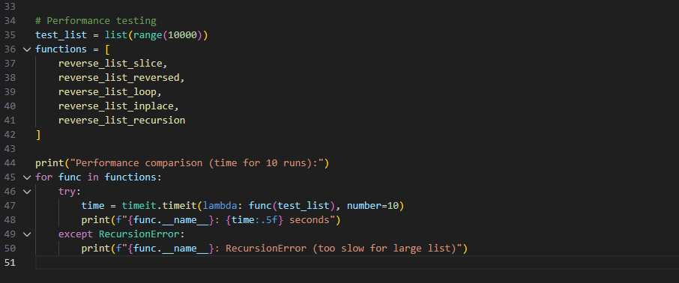

RESULT
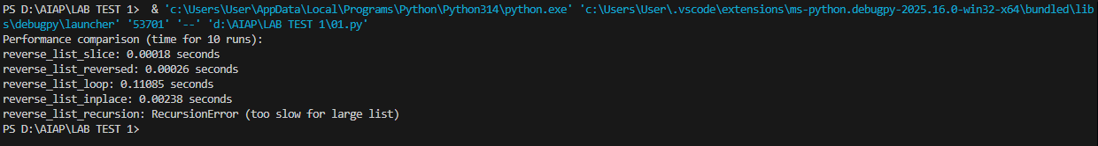
(Each question carries 5 marks)
- Q2. Design a few-shot prompt to guide an AI tool in writing code for a basic linked list with methods for insert and delete. Analyze the resulting code for correctness and completeness.
PROMT
Design a few-shot prompt to guide an AI tool in writing code for a basic linked list with methods for insert and delete. Analyze the resulting code for correctness and completeness.
GIVE SINGLE ACCURATE ANSWER
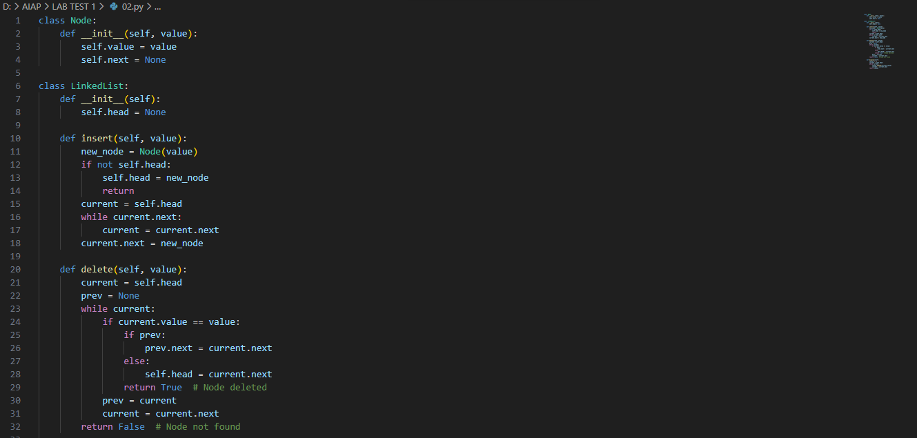
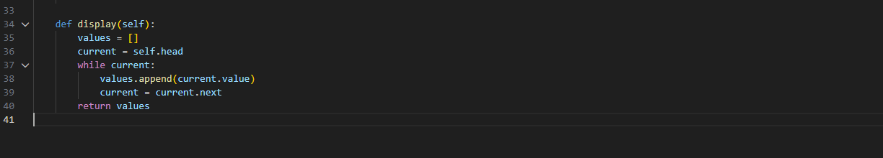
RESULT
(Each question carries 5 marks)

